**Exp No:** 1 **Implementation of Toy problem**.(Missionaries and cannibals)

**Date:** 23-01-2023

**AIM:**

In the missionaries and cannibals problem, three missionaries and three cannibals must cross a river using a boat which can carry at most two people, under the constraint that, for both banks, if there are missionaries present on the bank, they cannot be outnumbered by cannibals

**CODE:**

print("\n")

print("\tGame Start\nNow the task is to move all of them to right side of the river")

print("rules:\n1. The boat can carry at most two people\n2. If cannibals num greater than missionaries then the cannibals would eat the missionaries\n3. The boat cannot cross the river by itself with no people on board")

lM = 3

lC = 3

rM=0

rC=0

userM = 0

userC = 0

k = 0

print("\nM M M C C C | --- | \n")

try:

while(True):

while(True):

print("Left side -> right side river travel")

uM = int(input("Enter number of Missionaries travel => "))

uC = int(input("Enter number of Cannibals travel => "))

if((uM==0)and(uC==0)):

print("Empty travel not possible")

print("Re-enter : ")

elif(((uM+uC) <= 2)and((lM-uM)>=0)and((lC-uC)>=0)):

break

else:

print("Wrong input re-enter : ")

lM = (lM-uM)

lC = (lC-uC)

rM += uM

rC += uC

print("\n")

for i in range(0,lM):

print("M ",end="")

for i in range(0,lC):

print("C ",end="")

print("| --> | ",end="")

for i in range(0,rM):

print("M ",end="")

for i in range(0,rC):

print("C ",end="")

print("\n")

k +=1

if(((lC==3)and (lM == 1))or((lC==3)and(lM==2))or((lC==2)and(lM==1))or((rC==3)and (rM == 1))or((rC==3)and(rM==2))or((rC==2)and(rM==1))):

print("Cannibals eat missionaries:\nYou lost the game")

break

if((rM+rC) == 6):

print("You won the game : \n\tCongrats")

print("Total attempt")

print(k)

break

while(True):

print("Right side -> Left side river travel")

userM = int(input("Enter number of Missionaries travel => "))

userC = int(input("Enter number of Cannibals travel => ")

if((userM==0)and(userC==0)):

print("Empty travel not possible")

print("Re-enter : ")

elif(((userM+userC) <= 2)and((rM-userM)>=0)and((rC-userC)>=0)):

break

else:

print("Wrong input re-enter : ")

lM += userM

lC += userC

rM -= userM

rC -= userrC

k +=1

print("\n")

for i in range(0,lM):

print("M ",end="")

for i in range(0,lC):

print("C ",end="")

print("| <-- | ",end="")

for i in range(0,rM):

print("M ",end="")

for i in range(0,rC):

print("C ",end="")

print("\n")

if(((lC==3)and (lM == 1))or((lC==3)and(lM==2))or((lC==2)and(lM==1))or((rC==3)and (rM == 1))or((rC==3)and(rM==2))or((rC==2)and(rM==1))):

print("Cannibals eat missionaries:\nYou lost the game")

break

except EOFError as e:

print("\nInvalid input please retry !!")

**Sample Input and Output:**

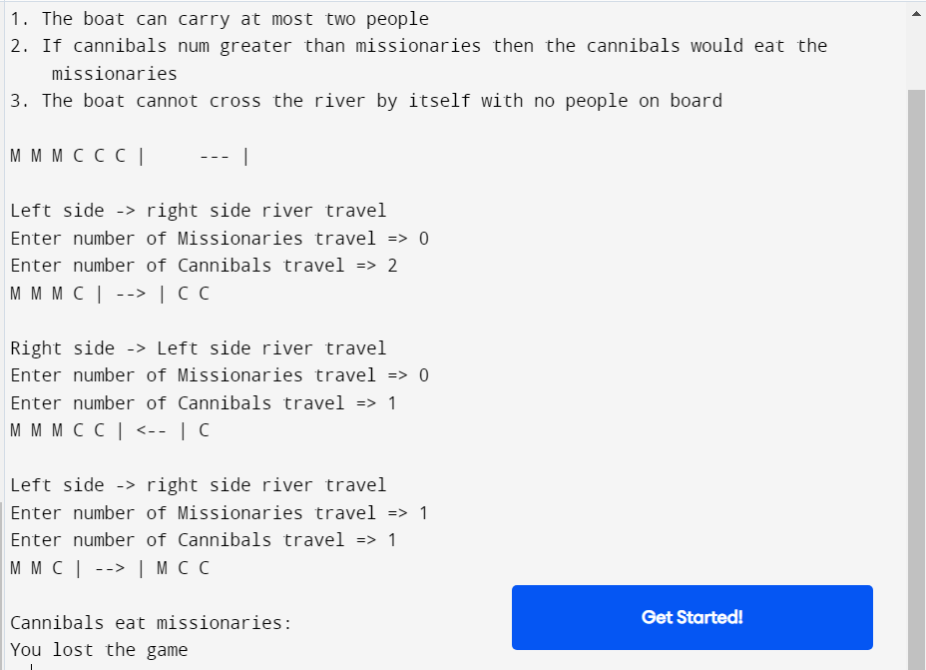

**Result:**

The missionaries and cannibal problem have been successfully implemented.